# **ANALYTICS ALL WORKSHEET**

## Features

* Saves screenshot of all LOB and Drilldown iteration for each workbook
* Validate if a year exists in worksheet
* Finds no data in the iterations

## Requirements : Pycharm , Python 3 , [DB Browser for SQLLite](https://sqlitebrowser.org/dl/)

[For Additional info on setup](https://docs.google.com/document/d/1db_SsGilZyH2d8P-Fn2HPDongL_FdDeIzd45iXKZ650/edit#heading=h.y1ezy75260yo)

## Setup

1. In python create a project “FilterHandlerAnalyticsAv”
2. Copy paste the files in Project folder of drive

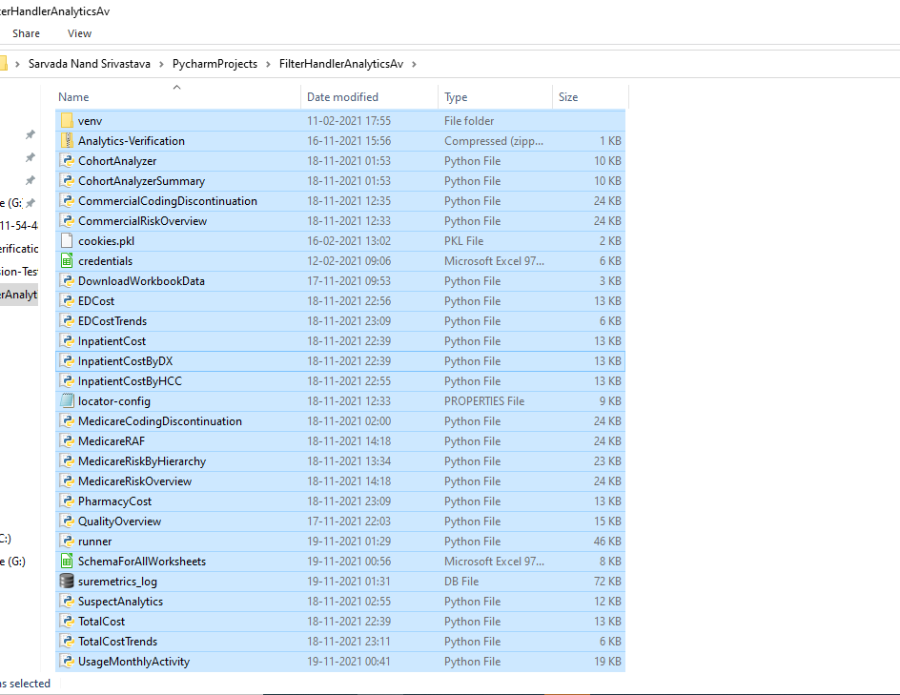

1. In locator-config.properties ;modify

[runner]

**chromedriverpath**=C:\\Users\\ssrivastava\\PycharmProjects\\Python_Practise\\drivers\\chromedriver.exe

**dbpath**=C:\\Users\\ssrivastava\\PycharmProjects\\FilterHandlerAnalyticsAV\\suremetrics_log.db

**login_file**=C:\\Users\\ssrivastava\\Documents\\credentials.xls

**user-data-dir**=C:\\Users\\ssrivastava\\PycharmProjects\\AritraMAnalytics\\UserFiles2

**downloaddefault**=C:\\Users\\ssrivastava\\PycharmProjects\\FilterHandlerAnalyticsAv\\Download

**report_directory_inpu**t=C:\\Users\\ssrivastava\\PycharmProjects\\FilterHandlerAnalyticsAV\\Report2\\

4. suremetrics.log can be opened in DB Browser for SQLLITe

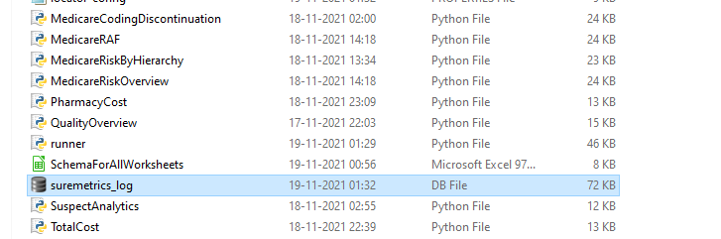

5.In SchemaForAllWorksheeets.xls file

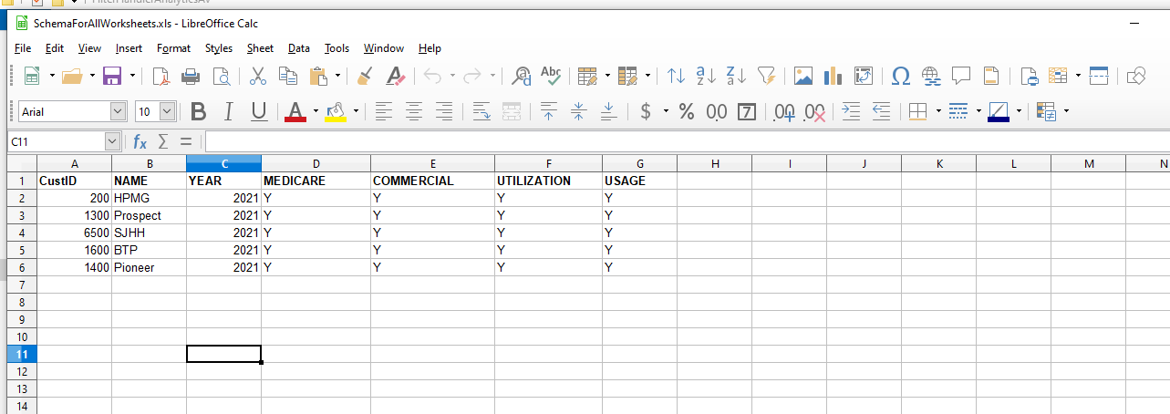

Update the above fields as Y or N ; based on the presence of the workbooks

In the Year column maintain one year as of now (2021/2020/2022 )

## Execution

## Execute the runner file

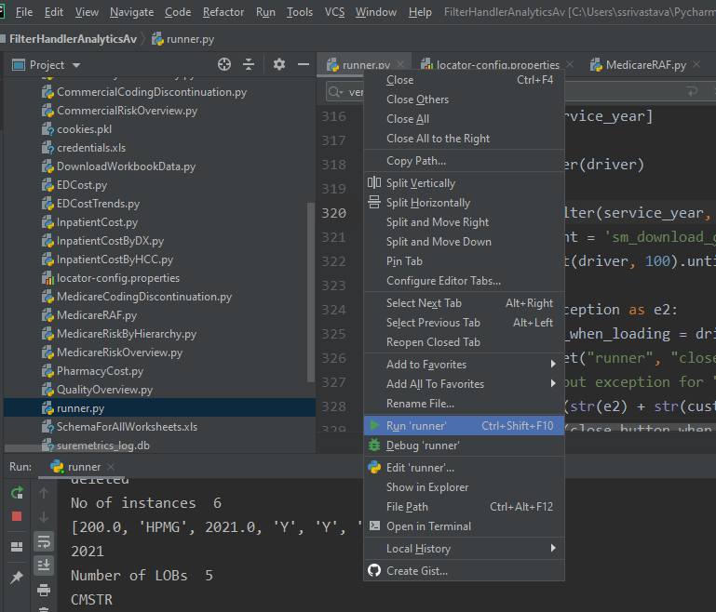

Console displays data found or not found at each page load

Number of no data displayed can easily be found by searching the console for “no data”

In Cohort Analyzer Summary Page ; console displays values of different records for quicker verification

## 

## Results

1. **Customer wise folde**r - It contains sub directories of the worksheets verified having the screenshots 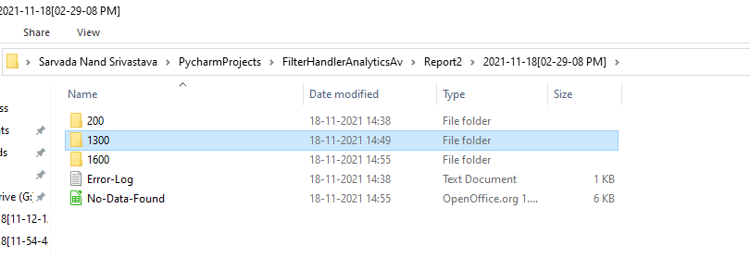

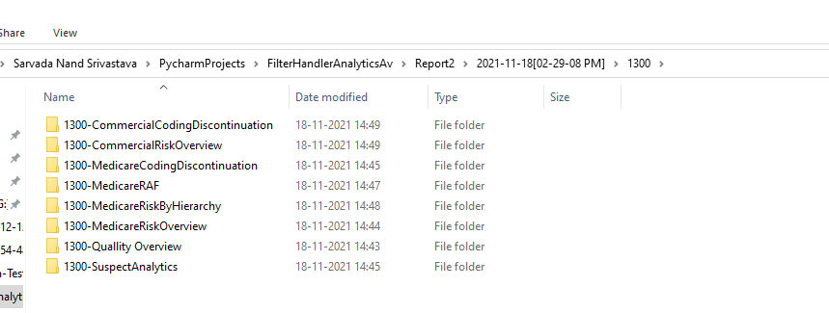

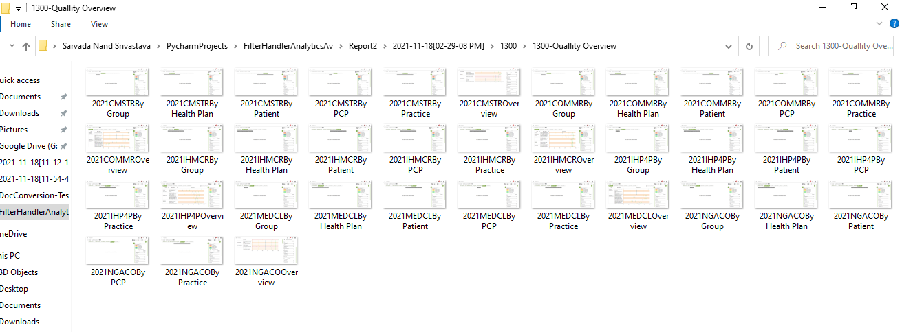

**2.Error File** - Displays the exceptions occurred while verification

It displays customer id and worksheet name and type of exception that led to skipping of the worksheet

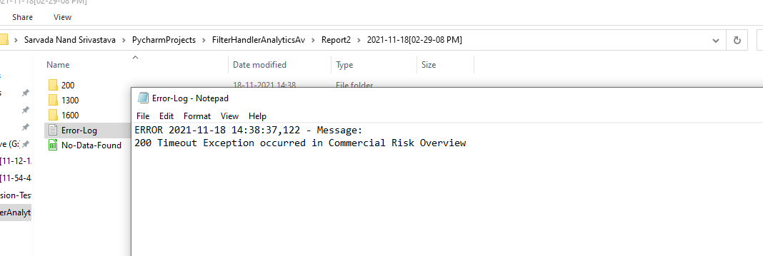

1. **No data found.csv** - Displays list of no data in csv format

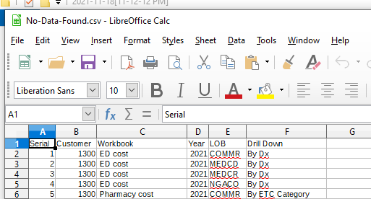

Important Points :

* For a customer one year could be validated at once
* IF any exception in any worksheet occurs; customer name and worksheet name and type of exception are logged in error file and execution begins for next worksheet

Verified for BTP , Prospect , HPMG , Altamed, SJHH

There are few worksheets yet to be included

1. Professional Cost
2. Risk Dashboard
3. Usage Summary
4. Specialist performance
5. Utilization risk assessment